SMART WATER FOUNDATION

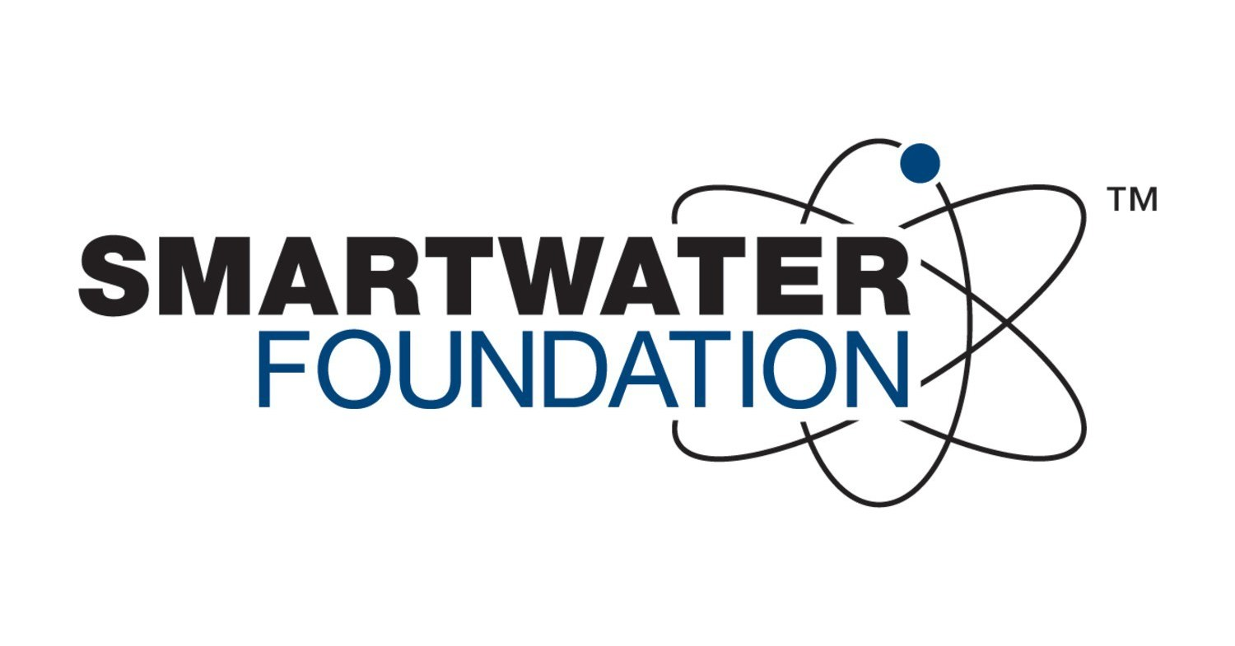

Abstract:

The Smart Water Foundation (SWF) is a pioneering initiative aimed at revolutionizing water management through the integration of cutting-edge technologies and sustainable practices. This abstract provides an overview of the SWF, outlining its mission, key modules, and the transformative impact it seeks to achieve in the realm of water resource management.

Module 1: Data Sensing and Collection

The foundation begins its mission by deploying advanced sensing technologies, including IoT devices, remote sensing, and water quality monitoring systems, to collect real-time data on water resources. This module forms the foundation for data-driven decision-making and proactive water resource management.

Module 2: Data Analytics and Prediction

SWF harnesses the power of big data analytics and machine learning to process and analyze the vast amount of data collected. Predictive models are developed to anticipate changes in water availability, quality, and demand, enabling informed decision-making and resource allocation.

Module 3: Water Resource Optimization

Efficient utilization of water resources is central to SWF's objectives. This module focuses on optimizing water allocation, distribution, and conservation strategies. It incorporates demand management, water recycling, and smart irrigation systems to ensure sustainable water use.

Module 5: Disaster Resilience and Preparedness

SWF is committed to enhancing water resilience in the face of natural disasters. This module involves the development of early warning systems, flood control measures, and disaster response strategies to safeguard water resources and communities.

Module 6: Technological Innovation Hub

The foundation operates as a hub for technological innovation in water management. It collaborates with research institutions and startups to foster the development of groundbreaking technologies and solutions for water-related challenges.

Through these modules, the Smart Water Foundation aims to create a holistic and sustainable approach to water management. By leveraging technology, community engagement, policy advocacy, and innovation, the foundation strives to address water challenges, promote water security, and ensure equitable access to this precious resource for generations to come.

Problem Solving for the Smart Water Foundation

The Smart Water Foundation is dedicated to addressing critical water-related challenges. Effective problem solving is essential to achieving its mission of transforming water management. Here's a structured problem-solving approach for the foundation:

1. Problem Identification:

- Begin by clearly identifying and defining the specific water-related problems the foundation aims to solve. Examples include water scarcity, water pollution, inefficient water distribution, or lack of access to clean water.

- Prioritize problems based on their urgency and potential impact on communities and ecosystems.

2. Research and Data Gathering:

- Conduct comprehensive research to understand the root causes and dimensions of the identified problems.

- Collect data on water resources, usage patterns, environmental impacts, and social factors contributing to the problem.

- Engage with local communities, scientists, experts, and stakeholders to gain diverse perspectives and insights.

3. Problem Analysis:

- Analyze the collected data to uncover patterns, trends, and underlying factors contributing to the water-related issues.

- Use tools like root cause analysis, SWOT analysis, and systems thinking to gain a holistic understanding of the problem's complexity.

- Identify key barriers and challenges that need to be addressed.

4. Ideation and Solution Generation:

- Organize brainstorming sessions and collaborative workshops involving multidisciplinary teams.

- Encourage innovative thinking to generate a wide range of potential solutions to the identified problems.

- Explore both short-term and long-term strategies, considering technological, policy, and community-based approaches.

6. Prototyping and Testing:

- Develop prototypes or pilot projects for the selected solutions.

- Test these solutions in real-world settings to assess their effectiveness and gather user feedback.

- Be open to making adjustments and improvements based on testing results.

.9. Community Engagement and Education:

- Engage with local communities and stakeholders to ensure their active participation and ownership of the solutions.

- Provide education and training on sustainable water management practices to empower communities to become stewards of their water resources.

10. Collaboration and Scaling:

- Collaborate with other organizations, governments, and international bodies to leverage resources and expertise for scaling successful solutions to a broader audience.

- Share knowledge, best practices, and lessons learned to contribute to a global network of sustainable water management.

Through this structured problem-solving approach, the Smart Water Foundation can effectively tackle water-related challenges, promote sustainable water management practices, and make a lasting positive impact on communities and the environment.

Design Thinking

Design Thinking is an approach that fosters innovation and problem-solving by prioritizing human needs and experiences. When applied to the Smart Water Foundation's mission of transforming water management, it can lead to creative and impactful solutions. Here is a Design Thinking framework tailored for the Smart Water Foundation:

1. Empathize:

- Start by deeply understanding the needs, challenges, and aspirations of communities, regions, and stakeholders affected by water management issues.

- Conduct field visits, interviews, and surveys to empathize with individuals and groups impacted by water scarcity, pollution, and inefficiencies.

- Create personas and empathy maps to synthesize insights and develop a human-centered perspective.

2. Define:

- Define the specific water-related problems and opportunities that the Smart Water Foundation aims to address.

- Reframe these challenges as opportunities for positive change and innovation.

- Create a clear problem statement that emphasizes the human and environmental aspects of the issues.

4. Prototype:

- Develop prototypes and pilot projects based on the most promising ideas generated during ideation.

- Prototypes can range from low-tech solutions like community rainwater harvesting systems to high-tech IoT-based water quality monitoring networks.

- Test these prototypes in real-world settings to gather feedback and refine the designs.

5. Test:

- Engage with communities and stakeholders to test the effectiveness of the prototypes in solving water-related problems.

- Collect feedback on usability, accessibility, and impact, with a focus on the human experience and sustainability.

- Iterate on the prototypes based on the feedback received from users and experts.

6. Educate and Engage:

- Develop educational programs and awareness campaigns to empower communities with knowledge about water conservation, pollution prevention, and sustainable practices.

- Encourage active participation and engagement from the communities in water-related projects.

7. Measure Impact and Sustainability:

- Continuously measure and evaluate the impact of the Smart Water Foundation's initiatives on water quality, availability, and community well-being.

- Assess the long-term sustainability of implemented solutions, considering economic, environmental, and social factors.

8. Share and Scale:

- Share success stories, best practices, and lessons learned with other organizations and regions facing similar water challenges.

- Collaborate with partners to scale effective solutions to a broader audience and create a global network for sustainable water management.

By following this Design Thinking framework, the Smart Water Foundation can create innovative and sustainable solutions that not only address water management issues but also prioritize the well-being of communities and the environment. Design Thinking encourages adaptability, empathy, and collaboration, essential qualities for tackling complex water-related challenges.